**DEPARTMENT**

**OF**

**DEFENSE**



**MOTOR VEHICLE SAFETY INITIATIVES**

**REPORT TO CONGRESS**

**March 27, 2003**

This report “DEPARTMENT OF DEFENSE MOTOR VEHICLE SAFETY INITIATIVES” prepared by the Department of Defense, Office of the Secretary of Defense, Deputy Under Secretary of Defense for Installations and Environment was developed as required by *House Report 107-732*.

***Table of Contents***

Chapter 1 Introduction 1

Preface 1

Background 1

Executive Summary 1

Statistics 1

Leadership 7

Initiatives 9

Chapter 2 United States Army Private Vehicle Safety Initiatives 11

Statistics 11

Analysis 15

Leadership 15

Initiatives 16

Chapter 3 United States Navy Private Vehicle Safety Initiatives 18

Statistics 18

Analysis 21

Leadership 21

Initiatives 21

Chapter 4 United States Air Force Private Vehicle Safety Initiatives 23

Statistics 23

Analysis 26

Leadership 26

Initiatives 27

Chapter 5 United States Marine Corps (USMC) Private Vehicle Safety Initiatives 29

Statistics 29

Analysis 32

Policies 33

Leadership 33

Initiatives 34

Chapter 6 Defense Agencies 37

Policy 37

Leadership 37

Initiatives 38

***List of Appendices***

Appendix A: US Army Safety Center POV ToolBox 40

Appendix B: US Naval Safety Center Traffic Safety Toolbox 41

Appendix C: US Air Force Safety Center 101 Days of Summer Toolbox 42

Appendix D: US Marine Corps Traffic Safety Media Coverage 43

Appendix E: US Army Europe *“*Click It or Ticket” Campaign 44

Appendix F: US Department of Defense Private Motor Vehicle Matrix 46

Appendix G: Congressional Requirement 47

***List of Figures***

Figure 1 “FY 2002 Types of Accidental Deaths” 2

Figure 2 “Trends of Private Vehicle Deaths Since 1990” 3

Figure 3 “Trends of Private Vehicle Deaths Since 1985” 3

Figure 4 “Trends of Private Vehicle Deaths from 1990 - 2002” 4

Figure 5 “Army Seatbelt Use” 12

Figure 6 “Army Deaths Involving Alcohol” 13

Figure 7 “Army Use of Motorcycle Helmets” 14

Figure 8 “Navy Seatbelt Use” 19

Figure 9 “Navy Alcohol Related Accidents” 20

Figure 10 “Navy Motorcycle Helmets Use” 20

Figure 11 “Air Force Seatbelt Use” 24

Figure 12 “Air Force Deaths Involving Alcohol” 25

Figure 13 “Air Force Use of Motorcycle Helmets” 25

Figure 14 “Marine Corps Seatbelt Use” 30

Figure 15 “Marine Corps Deaths Involving Alcohol” 31

Figure 16 “Marine Corps Use of Motorcycle Helmets” 32

***List of Tables***

Table 1 “FY 2002 Accidental Deaths” 2

Table 2 “Seat Belt Non-Use in Fatal Accidents” 5

Table 3 “Alcohol Related Private Vehicle Deaths” 5

Table 4 “Motorcycle Private Vehicle Deaths” 6

Table 5 “Motorcycle Deaths without Helmets” 6

Table 6 “Motorcycle Deaths with Training Class” 7

Table 7 “Army Private Vehicle Fatality Rates” 11

Table 8 “Army Four-Wheel and Two-Wheel Private Vehicle Deaths” 12

Table 9 “Army Europe *Click it or Ticket* Results” 14

Table 10 “Army Europe Alcohol Traffic Offenses” 15

Table 11 “Navy Private Vehicle Fatality Rates” 18

Table 12 “Navy Four-Wheel and Two-Wheel Private Vehicle Deaths” 19

Table 13 “Air Force Private Vehicle Fatality Rates” 23

Table 14 “Air Force Four-Wheel and Two-Wheel Deaths” 23

Table 15 “Marine Corps Private Motor Vehicle Fatality Rates” 29

Table 16 “Marine Corps Four-Wheel and Two-Wheel Private Vehicle Deaths” 30

**CHAPTER 1**

Introduction

**Preface**

The Conference Report to the Department of Defense Appropriations Act, 2003, (*House Report 107-732*) directed the Secretary of Defense to “submit to Congress a report on the personal motor vehicle safety statistics of each (military) service and the plans for each service to increase their efforts to reduce the level of deaths and injuries suffered by its personnel from motor vehicle accidents.”

**Background**

In *House Report 107-732*, page 122, Congress identified the leading cause of military members deaths as personal motor vehicle accidents, as opposed to training accidents or combat incidents, for fiscal years 2001 and 2002. In response, the Deputy Under Secretary of Defense for Installations and Environment, the proponent for Department of Defense (DoD) accident prevention policies, prepared this report with the assistance of subject matter experts from the Military Services and the Defense Agencies.

**Executive Summary**

The Office of the Secretary of Defense establishes overall DoD policies and procedures for Motor Vehicle Safety in DoD Instruction 6055.4, “*DoD Traffic Safety Program*”, which was revised on July 20, 1999. This revision emphasized seatbelt use, designated drivers, and behavior modification. This policy document is available at this Internet address: <http://www.dtic.mil/whs/directives/corres/html/60554.htm>. These policies apply to all DoD organizations on all bases worldwide. They ensure general uniformity while providing flexibility for the DoD organizations to best meet their accident prevention goals.

**Statistics**

In Fiscal Year (FY) 2002, there were 207 accidental deaths in the Army of which 113 (54%) were from private vehicle accidents. The Navy had 128 accidental deaths, of which 68 (53%) were from private vehicle incidents. Of the Air Force’s 113 accidental deaths, 71 (63%) were due to private vehicle accidents. The Marine Corps had 108 accidental deaths of which 61 (56%) were due to private vehicle accidents. Specific Military Service data and trend analyses are provided later in this report. In total there were 554 accidental military deaths in the four Services, 313 (56%) deaths that were due to Private Vehicle accidents. This is a number that must be reduced to zero. Table 1 displays this information.

|  |
| --- |
| ***Fiscal Year 2002 Total Military Accidental Deaths***  ***Compared to Military Private Vehicle Deaths*** |

|  |  |  |  |
| --- | --- | --- | --- |
|  | Total Accidental Deaths | PV Deaths | %PV |
| Army | 207 | 111 | 54% |
| Navy | 128 | 68 | 53% |
| Air Force | 111 | 71 | 63% |
| Marine Corps | 108 | 61 | 56% |
| Total | 554 | 312 | 56% |

Table 1 FY 2002 Accidental Deaths



Figure 1 FY 2002 Types of Accidental Deaths

In FY 2002, the Military Services sustained 67 aviation flight deaths, 312 private vehicle deaths and 174 other accidental deaths (due to training, operations, and other off-duty activities).



Figure 2 Trends of Private Vehicle Deaths Since 1990

Figure 2 shows the number of deaths each year for military personnel due to private vehicle accidents. The trend shows a steady decrease each year at a reduction rate of 21% until FY 2002.



Figure 3 Trends of Private Vehicle Deaths Since 1985

Figure 3 shows the trend from 1985 was decreasing at a rate of 31% until 2002. Notice the reduction of private vehicle deaths from over 700 per year in 1985 to 311 in 2002. If the number of deaths stayed constant at 700 per year, there would have been 9,800 deaths from 1989 to 2002. However aggressive prevention programs reduced the losses significantly. The sum of the losses saved (700-actual per year) equals over 5,041 lives saved.



Figure 4 Trends of Private Vehicle Deaths from 1990 - 2002

Figure 4 displays the declining number of private vehicle deaths from 1990 to 2001 (2002 was an increase) compared to the size of the military forces. The right vertical axis is the number of military personnel strengths in 100,000 amounts. While the Active Duty military personnel strength declined at a rate of 5%, the private vehicle deaths trends declined at a rate of 16% from 1990 to 2002, due to increased training, seat belt use, law enforcement, and the de-glamorization of alcohol. Also the Reserve Forces strengths declined 3%, but it cannot be used as a comparison since these military personnel when conducting Annual Training (AT) or Individual Duty Training (IDT) are counted as Active Duty personnel and likewise, their accidents are counted in the Active Duty statistics.

|  |
| --- |
| ***Private Vehicle Deaths Where***  ***Deceased Did Not Wear Seatbelts*** |

|  |  |  |  |  |  |
| --- | --- | --- | --- | --- | --- |
|  | Army | Navy | Air Force | Marine Corps | Total |
| 1998 | 38 | 15 | 13 | 16 | 82 |
| 1999 | 29 | 25 | 17 | 27 | 98 |
| 2000 | 29 | 11 | 20 | 16 | 76 |
| 2001 | 27 | 19 | 16 | 13 | 75 |
| 2002 | 24 | 18 | 18 | 25 | 85 |
| Total | 147 | 88 | 84 | 97 | 416 |

Table 2 Seat Belt Non-Use in Fatal Accidents

Table 2 shows the number of fatal military private vehicle accidents where the occupants did not wear seat belts. All of these are off duty accidents. While there were a few on-duty private vehicle deaths, they are not counted in this report.

|  |
| --- |
| ***Number of Private Vehicle Deaths Where***  ***Alcohol was a Factor*** |

|  |  |  |  |  |  |
| --- | --- | --- | --- | --- | --- |
|  | Army | Navy | Air Force | Marine Corps | Total |
| 1998 | 24 | 21 | 9 | 15 | 69 |
| 1999 | 17 | 25 | 4 | 15 | 61 |
| 2000 | 12 | 14 | 9 | 20 | 55 |
| 2001 | 24 | 23 | 14 | 11 | 72 |
| 2002 | 21 | 27 | 21 | 13 | 82 |
| Total | 98 | 110 | 57 | 74 | 339 |

Table 3 Alcohol Related Private Vehicle Deaths

Table 3 shows the number of private vehicle deaths where alcohol was a reported factor.

|  |
| --- |
| ***Number of Motorcycle Private Vehicle Deaths all Military Services*** |

|  |  |  |  |  |  |
| --- | --- | --- | --- | --- | --- |
|  | Army | Navy | Air Force | Marine Corps | Total |
| 1998 | 13 | 12 | 15 | 8 | 48 |
| 1999 | 21 | 15 | 11 | 6 | 53 |
| 2000 | 12 | 13 | 8 | 7 | 49 |
| 2001 | 15 | 11 | 9 | 6 | 41 |
| 2002 | 26 | 15 | 20 | 11 | 72 |
| Total | 87 | 66 | 63 | 38 | 263 |

Table 4 Motorcycle Private Vehicle Deaths

Table 4 shows the number of motorcycle private vehicle deaths in each of the Military Services. The Army has the highest with a total of 87 motorcycle deaths, with the Marine Corps having the least. Navy and Air Force are about equal. In 2002, the Air Force had their highest number of motorcycle deaths for the past five years.

|  |
| --- |
| ***Number of Fatal Motorcycle Accidents***  ***Without Use of Helmets*** |

|  |  |  |  |  |  |
| --- | --- | --- | --- | --- | --- |
|  | Army | Navy | Air Force | Marine  Corps | Totals |
| 1998 | 1 | 0 | 1 | 0 | 2 |
| 1999 | 4 | 3 | 3 | 1 | 11 |
| 2000 | 1 | 3 | 1 | 3 | 8 |
| 2001 | 5 | 1 | 1 | 3 | 10 |
| 2002 | 4 | 2 | 2 | 1 | 9 |
| Total | 15 | 9 | 8 | 8 | 40 |

Table 5 Motorcycle Deaths without Helmets

Table 5 (previous page) shows the number of motorcycle fatal accidents where helmets were not worn.

|  |
| --- |
| ***Number of Fatal Motorcycle Accidents***  ***Where Driver Had Completed Required Motorcycle Safety Training*** |

|  |  |  |  |  |  |  |  |  |  |  |  |
| --- | --- | --- | --- | --- | --- | --- | --- | --- | --- | --- | --- |
|  | | Army | | Navy | | Air Force | | Marine  Corps | | Totals | |
| 1998 | | 0 | | 6 | | 11 | | 1 | | 17 | |
| 1999 | | 1 | | 7 | | 8 | | 2 | | 18 | |
| 2000 | | 1 | | 6 | | 4 | | 2 | | 13 | |
| 2001 | | 0 | | 5 | | 7 | | 3 | | 15 | |
| 2002 | | 3 | | 5 | | 15 | | 7 | | 30 | |
| Total | | 5 | | 29 | | 45 | | 15 | | 93 | |

Table 6 Motorcycle Deaths with Training Class

Table 6 shows the number of motorcycle fatal accidents where the driver had the required motorcycle safety training.

**Leadership:**

In 1999, the DoD revised its Traffic Safety Program regulation; DoDI 6055.4 that combined DoD Directive 1010.7, “Drunk and Drugged Driving by DoD Personnel” and provided more focus on personal protective equipment for motorcycle operators and requires skill training provided by the Defense Department at no cost to the driver and no leave is charged to the attending personnel. It implements Executive Order 13043, *Increasing Seat Belt Use in the United States*, April 16, 1997. The policies in this instruction apply to all of the Military Services, the Defense Agencies, the Defense Activities, and the Army-Air Force Exchange Service. The policies apply to all military personnel at any time, on or off of a DoD installation; all DoD civilian personnel in a duty status, on or off a DoD installation; all persons in or on a DoD-owned motor vehicle; and all persons at any time on a DoD installation. It prohibits the wearing of headphones, earphones, or other listening devices while operating a motor vehicle; and, jogging, running, bicycling or skating on DoD installations. The use of those devices impairs driving and masks or prevents recognition of emergency signals, alarms, announcements, the approach of vehicles, and human speech. It also cautions about use of cell phones or global positioning systems in a moving vehicle and allows their use when the vehicle is safely stopped. The policies prohibit operators and passengers from having open containers of alcoholic beverages in their ready possession. All non-use of occupant protective devices (seat belts and child safety seats) is enforced as primary traffic violations.

The DoD policy also includes the requirement for a Service Impaired Driving Prevention Task Force (SIDPTF) chaired by the military service Designated Agency Safety and Health Official (DASHO). The SIDPTF is required to consist of representatives of the Services’ drug and alcohol programs and law enforcement communities.

For FY 2000, the Department of Defense Legislative Proposal contained a provision to amend the Uniform Code of Military Justice, to reduce, from 0.10 grams to 0.08 grams, the blood and breath alcohol levels for the offense of drunken operation of a vehicle, aircraft, or vessel. It became Section 562 of S 1059. The House Bill of the FY 2000 National Defense Authorization Act contained no similar provision. The Senate receded and the Conference report stated: “The conferees note that a recent General Accounting Office study (GAO/RCED-99-179) could not conclude that merely lowering the statutory blood alcohol level resulted in lowering the number and severity of alcohol-related traffic accidents. However, the report did find strong indications that a comprehensive approach, including license revocation and lowered blood alcohol statutes, public education campaigns, and increased enforcement would have that effect. The conferees directed the Secretary of Defense to submit a report to The Committee on Armed Services of the Senate and the House of Representatives before April 1, 2000, on the Department’s efforts to reduce alcohol-related disciplinary infractions, traffic accidents, and other such incidents. The report should include the Secretary’s recommendations for any appropriate legislative changes.”

The Department conducted a review and submitted the required report to the Chairman of the Senate Committee on Armed Services and to the Chairman of the House Committee on Armed Services on May 5, 2000.

DoD recommended in its report to Congress that the effectiveness of the existing DoD programs be further enhanced through the amendment of Article 111(2) of the Uniform Code of Military Justice, 10 U.S.C. § 911(2), to reduce the enforceable Blood Alcohol Count (BAC) level to 0.08.

Reducing the BAC level to 0.08 would be consistent with statutes or administrative policies already in effect in 19 states and the District of Columbia. (Six additional states currently have under consideration legislation to change to the 0.08 BAC level.) If enacted, DoD believes the 0.08 BAC limit will be an important component of our overall traffic safety program and support a significant reduction in the annual number of alcohol-related fatal and non-fatal crashes involving DoD personnel, with corresponding human and economic savings.

In 2000, the Department of Defense Occupational Health and Medicine departments organized a tri-service working group to reduce alcohol and tobacco abuse among our military personnel. The committee devised strategies to focus on military age groups with heavy alcohol use through surveillance, education and training; accessibility and availability; identification of high-risk groups; and, assessing and developing best practices. Much success was attributed to eliminating “happy hour” price reductions and providing alternative beverages and food where alcohol is served. This tri-service working group had the following successes:

* Acquired over $10M in alcohol-related research dollars through the Congressionally Mandated Medical Research programs.
* Sponsored the first ever DoD-wide alcohol seminar in which the program managers from all the Services were involved.
* Liaisoned with various civilian organizations e.g., Anheuser-Busch, Centers for Higher Education (colleges and universities), the Pacific Institute (legislative arm of MADD), and the Century Council to develop strategies to combat alcohol abuse.
* Conducted thorough reviews of all DoD and service policies regarding Education and Training and Leadership courses to ensure uniformity and identify gaps in education and personnel policies regarding alcohol abuse.
* Worked with DoD resale activities (Service Exchange systems) to ensure no deep discounting on packaged liquor (distilled spirits), beer, and wine.
* Developed action plans and a charter with milestones and objectives to bring about reduction of alcohol abuse.

**Initiatives:**

The General Accounting Office Report, dated June 1999*, Highway Safety, Effectiveness of State .08 Blood Alcohol Laws*, states that reduction to .08 is effective if combined with other laws and programs for Administrative License Revocation (ALR), comprehensive screening and treatment programs for alcohol offenders, vehicle impoundment and zero tolerance Blood Alcohol Count (BAC) laws for youth. The Department believes a comprehensive program is needed in DoD and further action by the Military Services is warranted.

The National Safety Council report, *Mired in Mediocrity*, dated May 2001, provided a Nationwide Report Card on Driver and Passenger Safety. The NSC used four simple criteria in their evaluation of each of the 50 states and the District of Columbia: NHTSA approved seat belt use rate, quality of occupant state protection laws, population weighted unrestrained deaths (three age groups), and law enforcement participation in the Operation ABC Mobilization. A similar grading system should be considered for the Department’s use at major installations.

Also contributing to the reduction of private vehicle deaths is the American Forces Information Service (AFIS), which is an office, aligned under the Under Secretary of Defense for Public Affairs. The AFIS organization can be found at <http://www.defenselink.mil/afis/>. For the past several years, AFIS has produced dozens of traffic and vehicle safety television and radio “spot” announcements, which play on the American Forces Network (AFN) overseas. AFIS announcements are widely distributed and have an outstanding effect informing the military and their families of safe driving practices, safe automobiles, and safe local conditions. For the coming year, motorcycle safety topics are being prepared in coordination with our military Service safety managers overseas and at our Service safety centers.

Each of the Military Departments has a dedicated Safety Center that supports their Chief of Staff and their field commands to reduce vehicle accidents. Each of the larger Defense Agencies has a dedicated safety manager who provides similar services for their employees. The Safety Centers and headquarters offices can be found at these Internet addresses:

US Army Safety Center: <http://safety.army.mil>

US Naval Safety Center: <http://www.safetycenter.navy.mil>

US Air Force Safety Center: <http://safety.kirtland.af.mil>

US Marine Corps Safety Office: <http://www.hqmc.usmc.mil/safety.nsf>

Defense Logistics Agency: <http://www.dla.mil/dss/dss-e/>

**Chapter 2**

**United States Army Private Vehicle Safety Initiatives**

**Statistics:**

***US Army Private Vehicle Deaths***

***And Fatality Rates***

***Fiscal Years 1998 - 2002***

|  |  |  |  |
| --- | --- | --- | --- |
|  | Active Duty Military Strength | Military PV Deaths | Fatality Rate |
| 1998 | 483,880 | 114 | 23.6 |
| 1999 | 479,426 | 124 | 25.9 |
| 2000 | 482,170 | 113 | 23.4 |
| 2001 | 480,801 | 99 | 20.6 |
| 2002 | 486,542 | 111 | 22.8 |
| Total | - | 561 | - |

Table 7 Army Private Vehicle Fatality Rates

*Note:* The military strength is listed at <http://www.dior.whs.mil/mmid/mmidhome.htm> by the Department of Defense Directorate of Information Operations and Reports (DIOR). The fatality rate above is calculated from the number of Military Deaths/Military Strength X 100,000.

***US Army Private Vehicle Deaths***

***Four-Wheel and Two-Wheel Vehicles***

***Fiscal Years 1998 to 2002***

|  |  |  |  |
| --- | --- | --- | --- |
|  | Four-Wheel  Vehicles | Two-Wheel Vehicles | Total |
| 1998 | 101 | 13 | 114 |
| 1999 | 103 | 21 | 124 |
| 2000 | 101 | 12 | 113 |
| 2001 | 84 | 15 | 99 |
| 2002 | 85 | 26 | 111 |
| Total | 474 | 87 | 561 |

Table 8 Army Four-Wheel and Two-Wheel Private Vehicle Deaths

Figure 5 Army Seatbelt Use

Figure 5 shows the number of Army private vehicle deaths for soldiers while wearing their seatbelts and those who did not wear their seatbelts. Since most of these are off the Army installations, local law enforcement authorities investigate many of these fatal deaths. Their investigation reports may not have identified the positive use of seatbelts. The number of seatbelts not used is probably accurate. The green bar is an assumption that seatbelts were worn, since it was not indicated if the seatbelts were not worn. There could be a significant number of not reported mixed in with the green bar.

Figure 6 Army Deaths Involving Alcohol

Figure 6 shows the number of Army deaths where the use of alcohol was involved with the fatal crashes. The green bar shows the number of fatal crashes that was stated no involvement on the accident report. It is important to notice is the high number of “alcohol-not reported” fatal accidents.

Figure 7 Army Use of Motorcycle Helmets

Figure 7 shows the number of Army soldiers who were wearing their helmets during motorcycle crashes. Further research is needed to understand the speed, weather conditions, etc., for each of the crashes.

***US Army Europe “Click It or Ticket”***

***Law Enforcement Results***

|  |  |  |  |  |
| --- | --- | --- | --- | --- |
| Holiday | POV Checked | Number of Tickets Issued-US Military Police | Number of Tickets Issued-Host National Police | Total Tickets  (%Tickets issued) |
| July 4th | 11,889 | 308 | 106 | 414 (34%) |
| Labor Day | 21,502 | 196 | 141 | 337 (16%) |
| Veteran’s Day | 17,216 | 110 | N/A | 110 (1%) |
| Total | 50,607 | 614 | 247 | 861 (17%) |

Table 9 Army Europe *“Click It or Ticket”* Results

***US Army Europe Law Enforcement***

***Alcohol-Related Traffic Offenses***

|  |  |  |  |  |
| --- | --- | --- | --- | --- |
| Holiday | Number of Offenders | Number Revoked Licenses | Number Suspended Licenses | Repeated Offender |
| Labor Day | 32 | 16 | 16 | 1 |
| Veteran’s Day | 21 | 17 | 4 | 2 |

Table 10 Army Europe Alcohol Traffic Offenses

Tables 9 and 10 show the results of the US Army Europe Law Enforcement program ensuring compliance with the seatbelt laws. In Table 9, the drivers ticketed were 50% lower over the Labor Day weekend compared to the July 4th weekend, even though the number of vehicles checked increased by 10,000 vehicles. Table 10 shows the relatively low number of alcohol-related traffic offenses, and the reduction from Labor Day holiday to Veteran’s Day holiday.

**Analysis:**

The most deadly threat that Soldiers face in peacetime is traffic accidents. Privately Owned Vehicle (POV) accidents kill more Soldiers than all other on and off-duty accidents combined**.** Failure to use protective equipment, such as seatbelts and motorcycle helmets, was reported in at least 118 military injury and fatal accidents between 1998 and 2002. The requested data is enclosed.

**Leadership**:

The Army’s senior leadership has made clear their determination to end this needless loss of Soldiers and the adverse impact it has on readiness. The following Chief of Staff, Army (CSA) directives are specifically targeted at preventing traffic accidents.

* CSA Message 141600Z Feb 00; subject: “Risk Management Campaign” directed commanders to follow the six-point model POV accident prevention program as the minimum standard for the Army.
* CSA Message 020722Z Aug 02; subject: “Safety, Risk Management, and Accident Prevention” directed major army commands to analyze their POV and army motor vehicle accidents and provide a summary of command initiatives to reduce accidental losses.
* CSA fourthquarter In Process Review (IPR) meeting, 25 September 2002. CSA directed commanders to increase enforcement of motorcycle safety training requirements. Commanders will not defer motorcycle safety training.

**Initiatives:**

The Major Army Commands (MACOM) have implemented the following specific POV accident prevention initiatives:

* The Training and Doctrine Command (TRADOC) implemented a Model Safety Program and self-assessment guide that incorporates the elements of the Army Six-Point POV Accident Prevention Program.
* The United States Army Europe (USAREUR) established a safety “Red Team,” chaired by the USAREUR Chief of Staff and implemented a broad-based attack on POV cause factors. Their program includes an accelerated media campaign using the Armed Forces Network television and radio; a radical change of standards for POV licensing which requires a stateside driver’s license in order to obtain a USAREUR Privately Owned Vehicle driver’s license; and a requirement for commanders to identify “high-risk” Soldiers. Their program also involved the National Safety Council in USAREUR’s *“Click It or Ticket”* campaign. The Army Europe program results are provided in Tables 10 and 11, discussed above. In June 2002, the Army Europe Chief of Staff directed the *“Click It or Ticket”* program to be implemented.
* The Army National Guard (ARNG) established a Motor Vehicle Task Force and developed a Strategic Motor Vehicle Action Plan, which includes doctrine, positive measurable metrics, and identified resources to accomplish the actions.
* The Army Forces Command (FORSCOM) implemented the Combating Aggressive Driving Program in conjunction with the American Institute for Public Safety, which received Congressional recognition and authorization for FY 2002. A FORSCOM Fatality Review Board, consisting of principal staff, medical doctors and psychologists, was established to identify accident causal factors and trends following each fatal accident. FORSCOM also established a FORSCOM News Service to promulgate safety articles and videos, such as motorcycle safety and POV safety, to installations’ Public Affairs Offices.

The U.S. Army Safety Center (USASC) had the following initiatives:

* Produced 11 “Drive to Arrive” infomercials, starring country music artists, delivering short to-the-point messages on specific driving hazards to Army Air Force Exchange Service (AAFES) theaters worldwide.
* “Every Drive Counts” is an unconventional safety video, set at the Airborne School, connecting safe high-risk training to off-duty activities, specifically POV driving. “Every Drive Counts” was presented the Government Star Video Award for FY 2002.
* The USASC web site (<http://safety.army.mil/>) contains a one-stop shopping POV accident prevention page, which includes the POV Toolbox <http://safety.army.mil/pov/index.html> and an updated Risk Management Information System at <http://rmis.army.mil>.
* The USASC flagship periodicals, *Countermeasure* and *Flightfax,* increasingly target traffic safety issues and lessons learned. The November 2002 issue of *Countermeasure* was dedicated exclusively to traffic safety.
* The USASC provides enhanced POV accident prevention training to each resident Safety Officer intern class and to aviation safety officers attending the Aviation Safety Officer Course.
* The USASC provides a mobile training team that travels worldwide to teach Junior Officer Safety and NCO Safety and Risk Management Courses.
* The USASC provides an Assistance Visit Team that travels to selected brigade and battalion size units to assist commanders, at their request, in assessing their safety programs, including their POV accident prevention programs.

The Army Safety Coordinating Panel (a general officer steering committee) chartered a POV Process Action Team (PAT) to assist the Army Chief of Staff for Installation Management (ACSIM) to develop, resource, and implement the Army-wide traffic safety program through the newly created Installation Management Agency (IMA). Resource requirements were briefed to the Army Program Objective Memorandum Budget Estimate Submission (POM BES) off-site in December 2002.

The Army Safety Coordinating Panel POV PAT identified four major elements to standardize, resource, and implement the Army-wide POV accident prevention program: Seatbelt Program; Motorcycle Safety; Drivers Education; and Impaired Driving Prevention.

The Joint Service Traffic Safety Task Force (JSTST) has been activated to promote   
inter-service cooperation in the development and implementation of effective traffic safety programs and to increase cooperation between the Services and other interested traffic safety organizations; such as *“Click It or Ticket”* campaign, accident avoidance training, and standardized motorcycle and All Terrain Vehicle (ATV) training.

For the future, a motorcycle safety video based on the successful “Every Drive Counts” and “Drive to Arrive” productions is currently under development.

**Chapter 3**

**United States Navy Private Vehicle Safety Initiatives**

**Statistics:**

***US Navy Private Vehicle Deaths***

***FY 1998 – FY 2002***

|  |  |  |  |  |  |  |  |
| --- | --- | --- | --- | --- | --- | --- | --- |
|  | | Active Duty Military Strength | | Military Private Vehicle Deaths | | Fatality Rate | |
| 1998 | | 382,338 | | 56 | | 15.95 | |
| 1999 | | 373,046 | | 66 | | 19.03 | |
| 2000 | | 373,193 | | 52 | | 14.20 | |
| 2001 | | 377,810 | | 55 | | 15.09 | |
| 2002 | | 385,051 | | 68 | | 19.48 | |
| Total | | - | | 291 | |  | |

Table 11 Navy Private Vehicle Fatality Rates

*Note:* The military strength is listed at <http://www.dior.whs.mil/mmid/mmidhome.htm> by the Department of Defense Directorate of Information Operations and Reports (DIOR). The fatality rate above is calculated from the number of Military Deaths/Military Strength X 100,000. The rate is calculated per 100,000 Sailor strength. Although a high percentage of Sailors are at sea and not driving vehicles, their strength is part of the calculation. The Naval Safety Center includes pedestrian and bicycle deaths in their Private Vehicle rate calculations; however those 26 deaths are not included in above numbers, since they are not caused by private motor vehicle accidents.

***US Navy Motor Vehicle Deaths***

***Four-Wheel and Two-Wheel Vehicles***

***FY 1998 – FY 2002***

|  |  |  |  |
| --- | --- | --- | --- |
|  | Four-Wheel vehicles | Two-Wheel vehicles | Total |
| 1998 | 44 | 12 | 56 |
| 1999 | 51 | 15 | 66 |
| 2000 | 39 | 13 | 52 |
| 2001 | 44 | 11 | 55 |
| 2002 | 53 | 15 | 68 |
| Total | 231 | 66 | 291 |

Table 12 Navy Four-Wheel and Two-Wheel Private Vehicle Deaths

Figure 8 Navy Seatbelt Use

Figure 8 shows the number of military private vehicle death where seatbelts were not worn compared to the total number of four-wheel vehicle deaths.

### Figure 9 shows the number of alcohol related deaths for Navy military personnel (four-wheel and two-wheel vehicles) compared to the total number of private vehicle deaths.

Figure 9 Navy Alcohol Related Accidents

Figure 10 shows the number of motorcycle fatal crashes that occurred and if the service member was wearing their required helmet. The figure also compares the number of crashes where the deceased had taken the required motorcycle training.

Figure 10 Navy Motorcycle Helmet Use

**Analysis*:***

* The deadly combination of night, speed, and non-use of seatbelts continues to claim lives of Navy personnel at an unacceptable rate. In addition, alcohol continues to claim the lives of many of our personnel.
* The data for the last five years is better than the five years prior and is considerably better than the data from ten or more years ago. Progress in reducing Navy deaths in motor vehicle crashes is being made too slowly, however.
* From FY 1998 through FY 2002, 68% of the Navy fatalities were age 25 or younger.
* The hours, 1AM to 4AM, proved to be the deadliest for traffic deaths.

# Leadership:

The Navy mandates seat belt use by Navy military personnel and their passengers both on and off base.

Prior to the recent Fall 2002 *“Click It or Ticket”* campaign, the Director of the Naval Safety Center’s Shore Safety Programs visited Navy Regional Commanders, conducted media interviews and assisted local commands in video taping Public Service Announcements to increase traffic safety awareness.

Motor Vehicle Safety Instructions and policy directives are being reviewed and updated to ensure they incorporate latest requirements.

**Initiatives:**

The Navy will expand their marketing and awareness initiatives for Navy-wide traffic safety mobilizations prior to semi-annual National Safety Council (NSC) “Click-it or Ticket” campaigns and will build upon Marine Corps and Navy successes achieved during the Fall 2002 campaign and increase site visits to Navy regions to promote future campaigns.

During the second quarter of FY 2003, Commander, Naval Safety Center will visit all Navy Regional Commanders and numerous individual activities to promote a three-pronged attack on PMV and Aviation Mishaps. The visits will stress the Leadership, Integrity and Cultural Change required to achieve and to sustain a marked improvement in Naval Aviation and Private Motor Vehicle (PMV) mishaps.

The Naval Safety Center plans the following initiatives:

* Develop a Traffic Safety Coordinator course to provide better guidance, best case practices and other resources for command Traffic Safety Coordinators. The course will focus on building a strong command Traffic Safety Program.
* Contract with a public relations firm to initiate a professionally developed traffic safety marketing campaign to reach the target population of 18-26 year olds.
* In conjunction with National Highway Traffic Safety Administration’s regional offices, establish and facilitate focus groups comprised of members aged 18-26. Focus groups will be established in Fleet concentration areas to identify specific traffic safety problems and make recommended solutions specifically targeting younger personnel.
* Establish new, and expand existing military-civilian community partnerships.
* Spearhead a Fleet-wide initiative to increase awareness and share lessons learned though the formation of mutually beneficial relationships between military and off base safety offices, medical facilities and law enforcement organizations. Maximize the creation of new partnerships to facilitate sharing of resources and knowledge.
* Though a partnership with other military Services and the Motorcycle Safety Foundation (MSF), assist in establishing a MSF Rider Education Training System (RETS) for military personnel. RETS addresses the changing demographics of motorcycling and offers a diversified program for both new and experienced riders.
* Form teams to assist Navy Inspector General (IG) inspectors in analyzing command traffic safety programs during IG visits. Safety Center personnel will inspect existing programs, and then actively train local personnel to develop tools to ensure their command establishes an effective and robust Traffic Safety Program.
* Revitalize Service participation on the Joint Traffic Safety Task Force (JTSTF) formerly commissioned by the individual Service Safety Chiefs. Use this excellent joint forum to share successes and address common traffic safety issues.
* Continue to publish the highly successful Summer Edition of *“Ashore”* Magazine dedicated to traffic safety. Over the past two years, the summer special edition has been one of the most widely read safety publications Fleet-wide. Additional printings of the magazine were required both years to meet growing Fleet demand.
* Send additional personnel to visit Commanding Officers, senior leaders, public affairs officers, and civilian safety managers in Fleet concentration areas to more aggressively promote future semi-annual NSC nation-wide “*Click It or Ticket*” seatbelt campaigns.

**CHAPTER 4**

**United States Air Force Private Vehicle Safety Initiatives**

**Statistics:**

***US Air Force Private Vehicle Deaths***

***FY 1998 – FY 2002***

|  |  |  |  |
| --- | --- | --- | --- |
|  | Military Strength | Military Deaths | Fatality Rate  (per 100,000 military) |
| 1998 | 367,470 | 31 | 8.4 |
| 1999 | 360,590 | 36 | 9.9 |
| 2000 | 355,654 | 34 | 9.5 |
| 2001 | 353,571 | 46 | 13.0 |
| 2002 | 368,251 | 71 | 19.29 |
| Total | - | 218 | - |

Table 13 Air Force Private Vehicle Fatality Rates

*Note:* The military strength is listed at <http://www.dior.whs.mil/mmid/mmidhome.htm> by the Department of Defense Directorate of Information Operations and Reports (DIOR). The fatality rate above is calculated from the number of Military Deaths/Military Strength X 100,000.

***US Air Force Motor Vehicle Deaths***

***Four-Wheel and Two-Wheel Vehicles***

***FY 1998 – FY 2002***

|  |  |  |  |
| --- | --- | --- | --- |
|  | Four-Wheel Vehicles | Two-Wheel Vehicles | Total |
| 1998 | 16 | 15 | 31 |
| 1999 | 25 | 11 | 36 |
| 2000 | 26 | 8 | 34 |
| 2001 | 37 | 9 | 46 |
| 2002 | 52 | 19 | 71 |
| Total | 156 | 62 | 218 |

Table 14 Air Force Four-Wheel and Two-Wheel Private Vehicle Deaths

Seat belts are critical in reducing the severity of a mishap. Seatbelt usage rate drops substantially to 47% (Figure 10) among those members involved in a Class A mishap. The Air Force says they are not satisfied with being above the national average; improvement in this can be realized through increased enforcement and emphasis both on our installations and in our surrounding communities.

Figure 8 shows the number of Navy military personnel who died in four-wheel private vehicle accidents where alcohol was involved compared to the number of total fatal crashes each fiscal year.

Figure 8 Air Force Alcohol Involved Fatal Accident

Figure 11 Air Force Seatbelt Use

Figure 11 shows the number of Air Force military personnel who were reported to have not been wearing their seatbelts and reported who were wearing their seatbelts in their fatal crash.

Figure 12 Air Force Deaths Involving Alcohol

Figure 12 shows the number of Air Force military personnel who were reported that alcohol was involved with their fatal crash in four-wheel and two-wheel private vehicles.

Figure 13 Air Force Use of Motorcycle Helmets

Figure 13 shows the number of motorcycle deaths by fiscal years. It also lists whether the person was wearing a helmet and if the deceased person had motorcycle training.

**Analysis:**

Motor vehicle deaths are the Air Force’s single greatest cause of accidental death. Since FY 1998 motor vehicle deaths have represented 70% of Air Force fatalities (excluding fatal aviation and weapons mishaps). The Air Force has experienced an unfavorable trend in motor vehicle mishaps over the last five years to include a particularly sharp increase in FY 2002. During this five-year period, the Air Force lost 218 Airmen to motor vehicle mishaps.

In the motorcycle (PMV-2) category, the Air Force experienced a sharp spike in fatal motorcycle mishaps in FY 2002. Overall PMV-2 mishaps resulted in 67 Class A; 9 Class B; and 660 Class C mishaps since FY 1998. There were seven on-duty PMV-2 mishaps during this period; therefore both on-duty and off-duty mishaps were combined in the total. Helmet usage is not a major problem for our Airmen. Across all classes of mishaps, usage rates are 93%, dropping to 87% for those members involved in Class A mishaps.

Airmen 18 – 25 years of age dominate the AF PMV mishaps. In FY 2002, this age group accounted for 70% of the fatal motor vehicle mishaps.

The overarching causes of our PMV mishaps are poor risk decisions and faulty judgment. These manifest themselves differently in PMV-4 mishaps and PMV-2 mishaps. Combining more than one of these behaviors was a deadly combination.

* For PMV-4 mishaps they are as follows (in order of magnitude):
  + - Impaired driving;
    - Speed too fast for conditions; and
    - Fatigue or over-extending oneself.
* For PMV-2 mishaps they are as follows (in order of magnitude):
  + - Exceeding capabilities / lack of proficiency;
    - Speed too fast for conditions; and
    - Impaired operators.

**Leadership:**

Command Emphasis: There has been and will continue to be focused command emphasis attacking the Air Force’s number one killer:

* Multiple messages from the CSAF and Major Commands (MAJCOMs) commanders highlighting trends and imploring personal risk management;
* MAJCOM commanders have made seasonal videos directly speaking to motor vehicle safety; and,
* Personal letters to the troops from Numbered Air Force (NAF) commanders following fatal mishaps.

The Air Force also employs seasonal campaigns: Since the early 1980s, the Air Force has emphasized PMV mishap reduction strategies during its annual 101 Critical Days of Summer (Memorial Day through Labor Day) and its winter holiday safety campaigns.

Upon every Permanent Change of Station (PCS), Air Force policy requires all members to receive local conditions orientation. This training addresses hazardous traffic and travel issues, peculiar laws or customs and unique driving conditions.

**Initiatives:**

Many MAJCOMs within the Air Force have publications dedicated to accident prevention, all of which carry articles dedicated to traffic safety and mishap lessons learned. The Air Force Safety Center has its own quarterly magazine dedicated to traffic and recreational safety: *Road & Rec*, winner of the 2002 Communicator Crystal Award.

MAJCOM commanders have directed Integrated Process Teams (IPTs) and focus groups on specific traffic safety issues such as the Air Forces’ IPT on motorcycle safety.

The Air Education and Training Command requires all members under 26 years of age to conduct and present a risk assessment in the form of a pre-trip plan prior to going on leave, Temporary Duty (TDY) or PCS. Additionally, they have introduced a Motorcycle Mentorship Program designed to assist new riders through their novice years.

The Air Force Space Command’s 20 Air Force commander commissioned a working group to address primarily Government Motor Vehicle mishaps. This has resulted in hands-on skid car training, gravel road operations training, travel conditions risk assessment all focused on reducing motor vehicle mishaps; undoubtedly there is significant transfer of behavior and skills to the private motor vehicle arena.

The US Air Forces in Europe is in its third year of its “26 and under” traffic safety program. This program mandates annual refresher training for persons less than 26 years of age.

In early FY 2002, the USAF chartered a Traffic Safety Integrated Process Team (IPT) to address their PMV challenges. The IPT and subsequent planning resulted in an Air Force traffic safety campaign plan, which addresses program enhancements and thorough traffic safety training revisions. The campaign plan includes:

* Traffic Safety Training Revision:
  + Field a suite of risk management based traffic safety training biased toward the “at-risk” age group.
  + Transition to the Motorcycle Safety Foundation’s revised curriculum.
  + Supervisory-level training to identify and address “at-risk” behaviors.
* Exploration – Initiatives for further study:
  + Partner with national traffic safety agencies to identify and benchmark common solutions.
  + Survey and gather marketing data to determine generational attitudes, goals and desires of “at-risk” audience – sell safety.
* Enhancements – Seek, develop and execute short, medium and long-term enhancements:
  + Partner with private industry, insurance companies, national advocate groups, etc.
  + Enforcement:
    - Law enforcement: e.g. “*Click It or Ticket*.”
    - Commander/Supervisory enforcement
  + Expand our Air Force traffic safety publicity campaign.
  + Field tools for commanders and supervisors:
    - Trip planning, Fatal Vision™ goggles and briefing materials.

The Air Force plans to update their traffic safety policy, AFI 91-207, *USAF Traffic Safety Program.*

The AF Chief of Safety’s Tome project; a ten-year critical analysis of Air Force mishap experience, is geared toward examining and identifying opportunities to achieve a world class safety culture. It can be found at <http://safety.kirtland.af.mil/AFSC/files/tome2.pdf>.

The Air Force is active in the recently revitalized Joint Traffic Safety Task Force (JTSTF) and hosted the February 2003 Joint Traffic Safety Training workshop.

**Chapter 5**

**United States Marine Corps (USMC) Private Vehicle Safety Initiatives**

**Statistics:**

***US Marine Corps Private Vehicle Deaths***

***FY 1998 – FY 2002***

|  |  |  |  |
| --- | --- | --- | --- |
|  | Military Strength | Military Private Vehicle Deaths | Fatality Rate |
| 1998 | 173,142 | 40 | 23.1 |
| 1999 | 172,641 | 49 | 28.5 |
| 2000 | 173,321 | 58 | 33.5 |
| 2001 | 172,934 | 31 | 17.9 |
| 2002 | 173,733 | 61 | 35.11 |
| Total | - | 239 |  |

Table 15 Marine Corps Private Motor Vehicle Fatality Rates

*Note:* The military strength is listed at <http://www.dior.whs.mil/mmid/mmidhome.htm> by the Department of Defense Directorate of Information Operations and Reports (DIOR). The fatality rate above is calculated from the number of Military Deaths/Military Strength X 100,000. The rate is calculated per 100,000 Marine strength. The Naval Safety Center includes pedestrian and bicycle deaths in their Private Vehicle rate calculations; however those 13 Marine Corps deaths are not included in above numbers, since they are not private motor vehicles.

***US Marine Corps Private Vehicle Deaths***

***Four-Wheel and Two-Wheel Vehicles***

***Fiscal Years 1998 to 2002***

|  |  |  |  |
| --- | --- | --- | --- |
|  | Four-Wheel Vehicles | Two-Wheel Vehicles | Total |
| 1998 | 32 | 8 | 40 |
| 1999 | 43 | 6 | 49 |
| 2000 | 51 | 7 | 58 |
| 2001 | 25 | 6 | 31 |
| 2002 | 50 | 11 | 61 |
| Total | 201 | 38 | 239 |

Table 16 Marine Corps Four-Wheel and Two-Wheel Private Vehicle Deaths



Figure 14 Marine Corps Seatbelt Use



Figure 14 shows the number of Marine Corps private vehicle deaths for Marines while wearing their seatbelts and those who did not wear their seatbelts

.



Figure 15 Marine Corps Deaths Involving Alcohol

Figure 15 shows the number of Marine Corps deaths where the use of alcohol was involved with the fatal crashes. The green bar shows the number of fatal crashes reports that was stated no involvement. Vehicles were four-wheel and two-wheel types.

Figure 16 Marine Corps Use of Motorcycle Helmets

Figure 16 shows the Marine Corps two-wheel private vehicle deaths compared to the number of fatal accidents where the riders were not wearing their helmets and the number who did have the required motorcycle training.

**Analysis:**

* Barring alcohol related deaths; the deadly combination of night, speed, and non-use of seatbelts continues to claim the lives of Marines at an unacceptable rate.
* The data for the last five years is not appreciably better than the previous five years, but is considerably better than the data from ten or more years ago. Thus, the Marine Corps is making progress, albeit too little and too slowly.
* During the same period as above, nine government vehicle accidents resulted in ten fatalities. None involved alcohol or non-use of seatbelts. One of the fatalities was a pedestrian fatality.
* For FY 1998 through FY 2002, 84% of Marine fatalities were 25 years old or younger. Seventy two percent of enlisted Marines are 25 years or younger.
* The first hour after midnight on Friday night is the single worst hour for traffic deaths.
* In FY 2002, 19 of the 65 deaths were passengers.

**Policies**:

* A Marine Corps (policy) Order mandates seat belt use by Marines and their passengers both on and off base. This requirement is punitive by a Marine Corps Order.
* The Marine Corps currently requires eight hours of driver improvement training. A Marine's permanent records indicate completion of driver training. The Marine Corps Inspector General (IG) has included driving training as a special interest inspection area.

**Leadership:**

## The Marine Corps’ latest efforts to reduce motor vehicle mishap fatalities began in September 2002 with the release of the Marine Corps-wide First Quarter FY 2003 Safety Theme: “Seat Belt Use”. This text message outlined the Marine Corps plan of attack for reducing motor vehicle fatalities, to include additional motor vehicle safety training and the convening of focus groups composed of the at-risk population of Marines. Additionally, the message solicited articles from throughout the Marine Corps detailing traffic accidents for inclusion in a special edition of “Ground Warrior” magazine dealing explicitly with traffic safety. The message also announced the Marine Corps’ partnership with the National Safety Council during the Thanksgiving “Click It or Ticket” campaign. The United States Marine Corps joined over 12,000 different agencies participating in the national “Click It or Ticket” campaign.

Throughout the first quarter, the Director of Safety for the Marine Corps, conducted site visits to installations throughout the Marine Corps and traveled with the Executive Vice President of the National Safety Council for Traffic Safety. These meetings increased awareness throughout the Marine Corps about traffic fatalities and ensured Corps-wide participation in the *“Click It or Ticket”* campaign.

During site visits, Base Commanding Generals, Commanding Officers, Safety Officers, Provost Marshall Officers, Public Affairs Officers, and state and local police agencies were briefed. Motor vehicles remain the largest killer of Marines and efforts to change this were the focus of the briefings. The meetings led to increased efforts between Provost Marshall Officers and local police agencies to share more information, such as the names of Marines ticketed off base for seatbelt violations.

Base and station newspapers throughout the Marine Corps printed stories on traffic safety and the Marine Corps participation in the national *“Click It or Ticket”* campaign, all aimed at increasing awareness throughout the Marine Corps. In addition to base and station newspapers, the National *“Click It or Ticket”* campaign was the subject of over 650 television news stories, many of which showcased the Marine Corps as the leader among the Department of Defense in zero tolerance for unbuckled Marines. Additionally, both the national *“Click It or Ticket”* campaign and the Marine Corps’ participation in it were noted in numerous newspaper and radio stations across the country.

Due to the partnership between the Marine Corps and the National Safety Council, the national kickoff of the *“Click It or Ticket”* campaign held at the Marine Barracks in Washington DC, received national media attention. The Assistant Commandant of the Marine Corps, General Spider Nyland was the featured speaker for the national kickoff. During his speech, he emphasized the Marine Corps’ commitment to reduce motor vehicle fatalities through continued partnership with the National Safety Council, augmented with traditional Marine Corps leadership involvement at all levels.

The Marine Corps leadership remains committed to reducing the toll of motor vehicle fatalities. As the smallest service within the Department of Defense, the Corps feels the effects of these tragedies more than any other military branch. Through continued education, leadership, accountability and ensuring that safety is a responsibility shared by every Marine, the Corps will continue to attack traffic fatalities with the same tenacity and ingenuity that the Marine Corps is known for. Currently, the Marine Corps Safety Division has one dedicated person to manage the Traffic Safety Program for the entire Marine Corps. While the Marine Corps has made positive changes in Traffic Safety, additional support would allow for more improvement. The Marine Corps is not satisfied to simply beat the national average for seatbelt usage. Long-term mishap reduction requires behavioral modification. Effectively modifying behavior throughout the Marine Corps requires analytic and marketing support.

**Initiatives:**

The Marine Corps goals and metrics for vehicular safety are included in the Safety Campaign Plan and the Strategic Plan.

In November 2002, across the Marine Corps, bases and stations conducted their own kickoff ceremonies of the *“Click It or Ticket”* campaign. For example, at Marine Corps Air Station Miramar, the base Commanding General, joined his Provost Marshall Officers as they conducted seatbelt checks. The base commander provided sodas and handshakes to personnel who were buckled up, while unbuckled personnel were immediately sent to ride in the Seatbelt Convincer and then issued a ticket. Of note, there were no Marines unbuckled aboard the base. As part of Marine Corps Base Camp Lejeune’s *“Click It or Ticket”* campaign, personnel caught driving aboard the base unbuckled lost their base driving privileges for 30 days. When the campaign began, military members made up the majority of those cited. Now, 80% of personnel cited are civilians.

The Marine Corps’ commitment to reducing traffic fatalities extends beyond our participation in nationwide *“Click It or Ticket”* campaigns. Numerous efforts remain on going to ensure long-term success in this effort. All Marines under the age of 26 are required to attend a certified Driver Improvement Course. Marine Corps Training and Education Command is spearheading the development of a computer-based version to increase the availability of the training to remote units. Additionally, to decrease the burden on the operating forces and reach Marines at their most receptive point, Marine Corps Recruit depot Paris Island is now conducting initial Driver Improvement Training for all recruits during Boot Camp. Periodic peer focus groups will be held to refine efforts at aimed at our at-risk population. A study was instituted at the Center for Naval Analysis to develop leading indicators for at-risk Marines. Areas under investigation as leading indicators include time since Boot Camp, injuries from vehicle accidents, and driving records/traffic violations.

The USMC Seat Belt Campaign also includes changing the behaviors of the Marine families. Every time a vehicle is stopped at a seat belt checkpoint, child safety seats installed in the vehicle are also inspected for proper installation and use. In 1998, Headquarters Marine Corps Safety Division and Marine Corps Community Services instituted a program called Bucklebear. This initiative provided increased education about child traffic safety and remains ongoing. During the current *“Click It or Ticket”* campaign, Marine Corps Safety Division bought 100 child safety seats for use in the Fleet Marine Forces. The health and welfare of our families is vital to the readiness of our individual Marines, and we are committed to their safety.

In addition the Marine Corps have the following initiatives:

* Developing a Marine Corps oriented driver improvement computer based course managed by Training and Education Command and annotated in each Marine's record.
* Continuing participation in nation-wide traffic safety mobilizations such as the "*Click-it or Ticket*" campaign.
* Expand relationships formed for the traffic safety mobilizations into "safe communities."
* Increased site visits to commands, e.g., Safety Division visited all major commands for “*Click-it or Ticket.*”
* Hold periodic peer focus groups at the installation level to determine how best to reach the “at-risk” age group.
* Conduct regular trend analysis to identify areas requiring attention such as recreational vehicles and All Terrain Vehicles (ATVs).
* Instituted Center for Naval Analysis study to determine leading indicators for at-risk Marines. Areas under investigation include time since Boot Camp, injuries from vehicle accidents, driving record and/or traffic citations.
* Publish special traffic issue of "*Ground Warrior*" annually.
* Produce additional traffic safety public service announcements.
* New video “Doing it Right "being produced showing a positive view of vehicular safety.
* Continuing efforts to build awareness of family members and civilians about child safety seat restrictions and seat belt laws.
* Incorporation of PMV Driver Improvement safety training into recruit depot curriculum.
* Growing number of Motorcycle Clubs to promote motorcycle safety.
* Saturday Seatbelt Class for violators.
* Use of Small Unit Leader program on drinking responsibly, along with a downward trend in alcohol-related vehicular fatalities.
* Increasing unit the use of “*Arrive Alive”* program, providing taxi rides home for drinking or drowsy drivers.
* Pilot testing of National Safety Council “*Alive at 25*” course targeting young drivers.

**CHAPTER 6**

**Defense Agencies**

Several of the larger Defense Agencies have established formal safety programs like the Defense Logistics Agency (DLA), Defense Threat Reduction Agency (DTRA), Defense Finance and Accounting Service (DFAS), Defense Contract Management Agency (DCMA), National Imagery and Mapping Agency (NIMA), Department of Defense Education Activity (DoDEA), Washington Headquarters Service (WHS), Defense Commissary Agency (DeCA), Army-Air Force Exchange Service (AAFES) and have very few off-duty military accidents for private vehicles or for other causes.

**Policy:**

Each of the Defense Agencies has formal polices to wear seatbelts while driving on and off base, whether on or off duty.

**Leadership:**

Several notable leaders among the Defense Agencies are the American Forces Information Services (AFIS) and the DoD Educational Activity and the Washington Headquarters Service.

The AFIS continuously produces radio and TV programs being aired everywhere outside the United States of America. The AFIS has produced numerous driving safety programs for our military and families living outside the country. Their scripts warn about driving hazards and precautions to be taken in other countries.

The DODEA manages the School Bus Safety Program for all of DoD dependent schools. They are exceptional with promotional material for the parents and their school children reminding them that the laws and customs of the United States do not apply in other countries, and may produce traffic hazards. The contracts written by DoDEA are very specific for driver qualifications and procedures to protect our military family children. In the many years DoDEA has been managing their school bus program, they have not have a child death or serious bus accident. We are very proud of DODEA for these efforts.

The Washington Headquarters Service (WHS) manages the buildings and related services in the Pentagon and National Capital Region. They provide several important services to reduce private vehicle accidents. WHS specific program and plans for motor vehicle safety includes efforts to reduce POV use:

* Transit fare subsidies ($26.6 million in 2002, with 29,565 employees participating).
* Preferential parking for carpools and vanpools (2,075 spaces).
* Pentagon Motor Pool with shuttle buses, limos/trained drivers for VIPs, and vans for official use. Safety/seat belt instructions are posted in vehicles.
* Pickup/drop-off points for large/informal network of SLUG riders who use carpools on Virginia High Occupancy Vehicle (HOV) lanes.
* Coordination with Virginia Department of Transportation (VDOT) to reduce traffic congestion during reconstruction of the Springfield Interchange and Woodrow Wilson Bridge.
* Accommodations for bicyclists and walker/joggers (39 bike racks with 667 spaces, 26 showers, and 5,893 lockers in 15 facilities).

WHS Encourages Use of Mass Transit:

* The Pentagon METRO Station is busiest inter-modal station in WMATA’s system.
* New $26 million Pentagon Bus Station (About 700 buses per day on 300 routes) and Metro Entrance Facility (34,000 people per day).
* Thirteen shuttle bus routes between Pentagon, federal buildings, and leased facilities in the National Capital Region.

WHS Motor Vehicle Safety Specifics:

* “Conduct on the Pentagon Reservation,” Federal Property Management Regulations, 32 CFR Part 234, including vehicles and traffic safety (32 CFR 234.17), is prominently displayed all over the Pentagon Reservation.
* Building Circulars frequently address road and parking lot construction and other activities for safety purposes.
* The Pentagon Force Protection Agency (PFPA) provides patrols, directs traffic, enforces rules, writes tickets, etc.
* The PFPA provides driving safety and traffic condition messages at building entrances and over the new Computer Emergency Notification System (CENS).
* Vehicle operators need vehicle licenses with current safety inspections to obtain parking permits on the Pentagon Reservation.

**Initiatives:**

Each of these Defense Agencies plans to be involved with the Memorial Day *“Click It or Ticket”* campaign for their immediate buildings as well several are participating for nation wide implementation.

Two outstanding efforts are being planned by the Defense Commissary Agency (DeCA) and the Army-Air Force Exchange Service (AAFES) with the *“Click It or Ticket”* national program for the 2003 Memorial Day weekend.

DeCA, who feeds the military family, plans to further reduce private vehicle accidents with each family, in support of the DoD initiative includes:

* Distribution of the *“Click It or Ticket”* campaign information to all DeCA worldwide activities prior to Thanksgiving Day and before Memorial Day.
* Addressing POV accident prevention issues in our annual DeCA Safety Week activities.
* Coordination with local installations to place flyers in shopping bags or making space available for a display table/rack for customer self-pickup.
* Running periodic canned POV accident prevention announcements in stores on DeCA radiobroadcast systems.
* Displaying installation procured *“Click It or Ticket”* promotional banners and posters in the commissary stores.
* Publishing DeCA “*Vision*” Magazine article just prior to Memorial Day promoting DoD POV accident prevention initiative awareness.
* Coordinating display/operation of seat belt demonstrators in front of Commissary.
* If feasible, printing of *“Click It or Ticket”* messages on sales receipts.

The AAFES will aggressively support the 2003 Memorial Day weekend *“Click It or Ticket”* campaign in all of their stores. The AAFES currently emphasizes private vehicle safety with “new hires”, as AAFES allows (requires) extensive use of personal vehicles for government use. (This may cause more careful driving; however accidents insurance claims must be filed with own insurance company before the government gets involved. Thus their premiums are increased or their policies are cancelled for business use of their private vehicle on government business.

The Defense Contract Management Agency currently has no mechanism in place to track on or off duty private vehicle accidents. However, DCMA is developing their own accident reporting database that is expected to be implemented Agency-wide in February 2003. All accident reporting data will be captured in this database.

**APPENDIX A**

**US Army Safety Center POV ToolBox**

(<http://safety.army.mil/pages/pov/povinfo.html>)

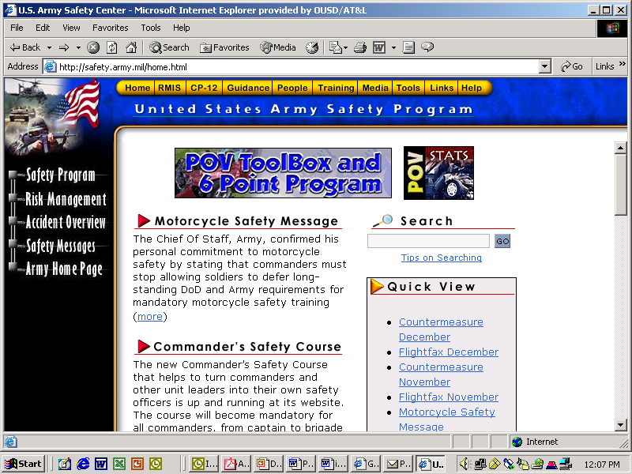

**APPENDIX B**

**Naval Safety Center Traffic Safety Toolbox**

(<http://www.safetycenter.navy.mil/ashore/motorvehicle/toolbox/default.htm>)

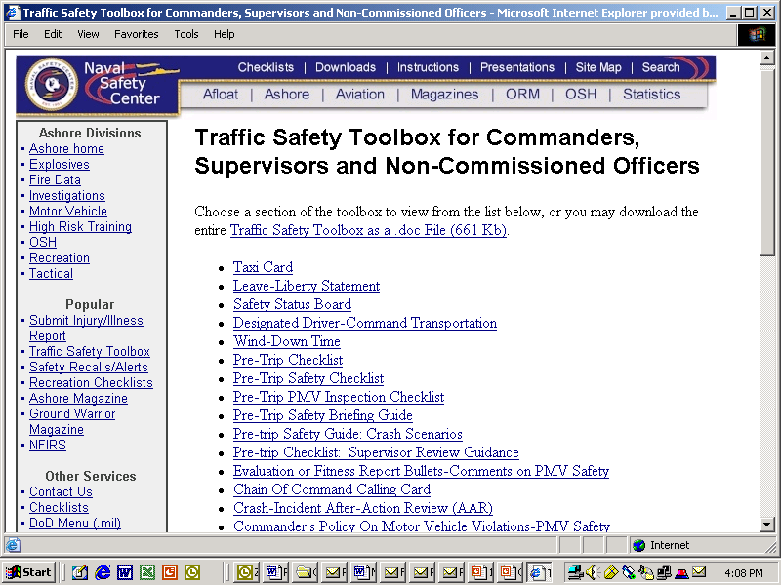

**APPENDIX C**

**Air Force Safety Center 101 Critical Days of Summer Campaign**

**(**<http://www.airforce> **safety.af.mil)**

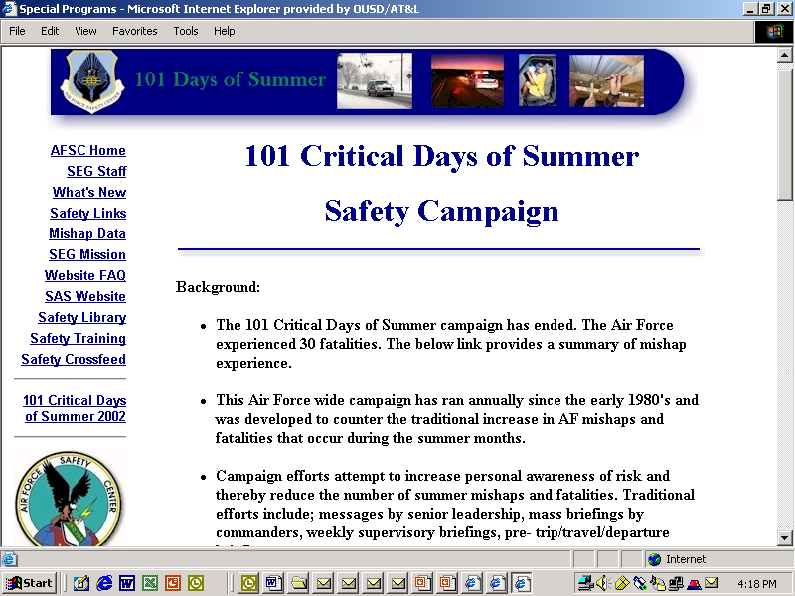

**APPENDIX D**

**Marine Corps Traffic Safety Media Coverage**

## Headquarters Marine Corps Web page announcing “Click It or Ticket” Campaign, AP News Release and San Diego Union Tribune article.

## ciot-usmcusmc

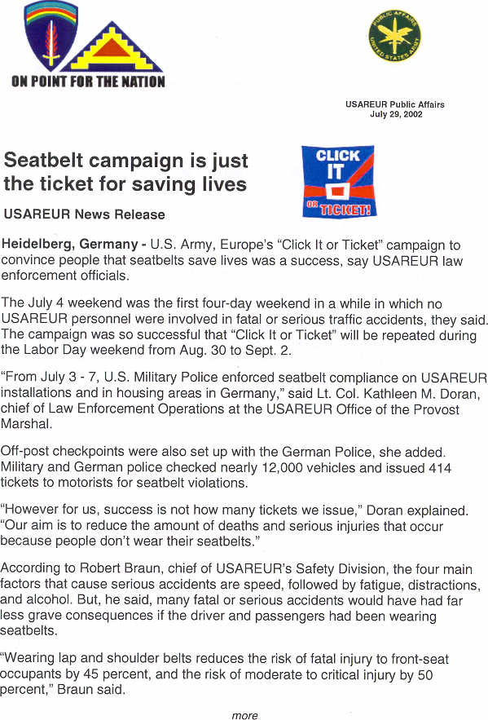**APPENDIX E**

**US Army Europe *“Click It or Ticket”* Campaign**

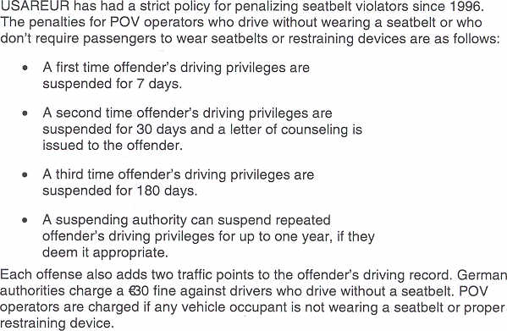

**APPENDIX F**

**Department of Defense**

**Private Vehicle Accident Matrix**

The Department of Defense monitors the daily accident trends at this public available address:

<http://www.denix.osd.mil/SOH-public/PMV>

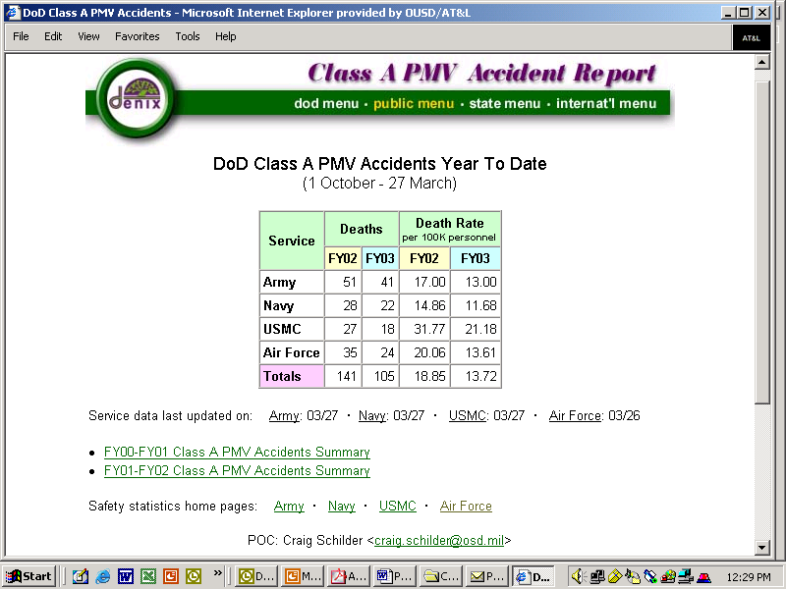

The matrix shows Year to Date comparisons from previous year to the same date. Previous End of Years is also hot linked for information. The currency of the data is shown by the dates under the matrix. Hotlinks are provided for quick access to Service Safety Center data. The email address of the DoD Safety Engineer is also provided for questions.

**APPENDIX G**

**Congressional Requirement**

House Report 107-732. DEPARTMENT OF DEFENSE MOTOR VEHICLE SAFETY INITIATIVES

(a) REPORT REQUIRED- Within 90 days of enactment of this Act, the Secretary of Defense shall submit to Congress a report on the statistics and plans to prevent personnel motor vehicle deaths.

(b) CONTENT OF REPORT- The report shall include the following:

(1) Summary of personal motor vehicle safety statistics by service for last 5 years.

(2) Outline of plans of each service to increase efforts to reduce deaths and injuries suffered by its personnel from motor vehicle accidents.